WRONG MESSAGING ON INSTANT ORDER CONFIRMATION and RETURNS
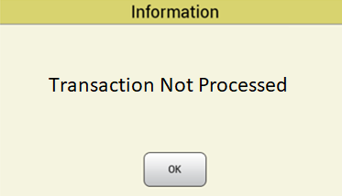
We are aware of an ongoing, intermittent, issue with the message that is displayed when you try to receive or return instant ticket books. We are current working to resolve this issue and can provide an alternative, temporary, solution.

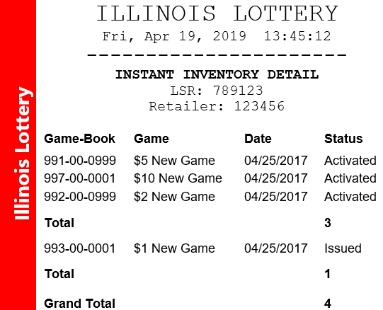

SOLUTION 1: RECEVING AN INSTANT ORDER ERROR
When attempting to receive an order that was shipped, the resulting message for the transaction MAY SOMETIMES read, “TRANSACTION NOT PROCESSED”.
Check if the order was received successfully by running the “Inventory Detail” report under the Instant Games Tab. This report will show all the Instant books that the retailer has in inventory. Use this report to verify the correct books are in the “Confirmed” status.
SOLUTION 2: RETURN BOOK ERROR
When you try to return instant books, you MAY SOMETIMES receive a message that reads, “TRANSACTION NOT PROCESSED”.
Check if the book was returned successfully by running the “Inventory Detail” report under the Instant Games Tab. This report will show you all the Instant books that the retailer has in inventory, you should no longer see the books that were returned.
LSRs can also use the Book History report to check if returns were successful.
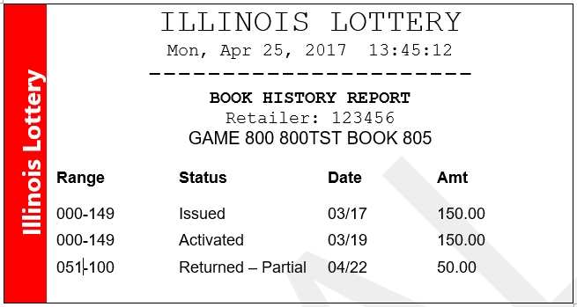

If you do not see the order or the book in the correct status, please contact the
Illinois Lottery Retailer Helpline at 1-844-806-8930 Option 6

